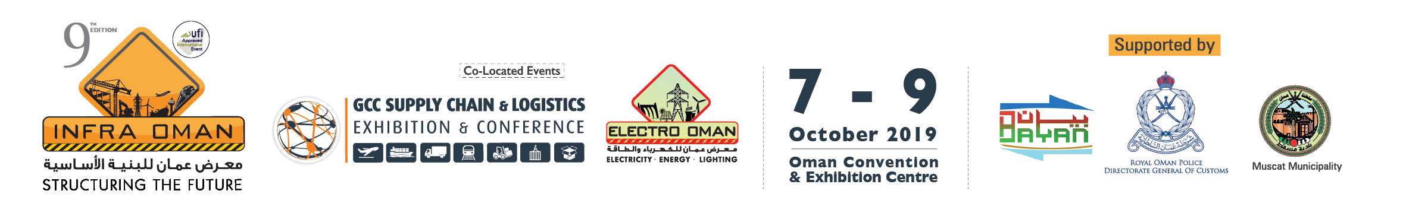

Dear Sir,

Al Nimr Expo would like to invite you to participate and have a strong presence in the Oman’s only major Construction & Infrastructure event of the Sultanate – Infra Oman 2019 to be held from 07 - 09 October 2019 at Oman Convention & Exhibition Centre (OCEC) and will be co-located with;
- GCCSCL, it will be dedicated to logistics services, shipping, maritime services and investment opportunities.
- Electro Oman, it will be dedicated solely to energy, power, electricity, water, lighting and HVAC sectors with a special emphasis on sustainable solutions and renewable energies.
The exhibition aims to contribute in meeting the growing requirements of the construction, infrastructure, Logistics, Power and other industry sectors. It is considered as the annual meeting place for industry leaders, suppliers and buyers in the Sultanate of Oman. Infra Oman has proved to be an ideal starting point not only for the local companies, but also for foreign entities that are more determined to be part of Oman’s growing market.

The 2018 edition featured over 250 companies locally and internationally and attracted more than 7000 industry professionals.
Highlights of Infra Oman 2018 can be seen @ https://www.youtube.com/watch?v=U9X3OgIG-bU&t=41s
Product Sectors:
- Building & Construction | - Building Materials | - Contracting & Consulting
- Cement & Concrete Products | - Construction Tools & Supplies | - Construction Vehicles & Equi.
- Cranes Earthmoving Equipment | - Electrical Products | - Fire Safety & Security Systems
- Formwork & Scaffolding | - Heavy Equipment & Technology | - HVAC
- Iron, Metal & Steel Products | - Infrastructure Projects | - Industry & Manufacturing
- Lighting Systems & Technologies | - Power & Renewable Energy | - Road Construction Machinery
- Steel Manufacturing | - Transport & Logistics | - Water & Environment

Outlined below the Stand options:
Stand Option | Price (USD)
Shell Scheme (Minimum 9sqm) | USD 3,285/-
Space Only (Minimum 18sqm) | USD 5,670/-

Awaiting your comments to discuss further about your participation in the 9th Infra Oman 2019.

The 2018 Photo Gallery: https://www.facebook.com/pg/infraoman/photos/?tab=album&album_id=1912831715470765
The Post Show Report 2018 can be reviewed @ http://www.infraoman.com/downloads/Post%20Show%20Report%202018.pdf
The 9th Infra Oman 2019 Brochure @ http://www.infraoman.com/downloads/Infra%20Oman%202019%20-%20Brochure.pdf

BR,

Muhammad Adil Osman
General Manager | +968 94041717 | media@alnimrexpo.com
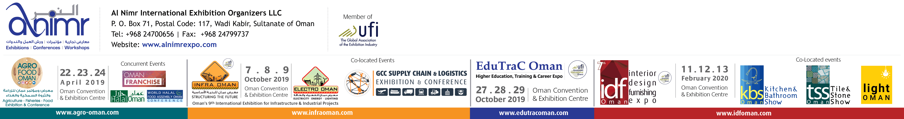
Let us join together to save our environment…

